YCompany – E-Claim Portal
Design Document

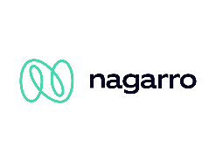
Nagarro Software Pvt. Ltd.
Microsoft Architecture Group

Revision History
Version | Date | Author/Contributor | Comments
1.00 | 24-04-2022 | Manish Kumar | Prepared Initial Phase
1.01 | 15-08-2022 | Manish Kumar | Updated Application Architecture

Contents

1. Introduction 6
2. System Overview 7
3. Requirement 8
3.1 Business Requirement 8
3.2 Functional Requirement 8
3.2.1 Web application: 8
3.2.2 Alert and Notification System 9
3.2.3 3rd Party Integration 10
3.2.4 Reporting 10
4. Technology Overview 11
5. Assumptions 15
5.1 In scope 15
5.2 Out of Scope 15
6. NFR Considerations 16
6.1 Usability 16
6.2 Reliability 16
6.3 Performance 17
6.4 Security 18
6.5 Supportability 19
6.6 Auto Scalability 20
7. Solution Architecture 21
7.1 High Level Solution Diagram 21
7.2 Components Description 22
7.2.1 API Gateway: 22
7.2.2 Microservice: 22
7.2.3 Cross Cutting Concern 22
8. Application Architecture 23
8.1 Architecture Diagram 23
8.2 Modules Description 24
8.2.1 API Gateway: 24
8.2.2 Microservices Decomposition Pattern 24
8.2.3 Sidecar Design Pattern: 25
8.2.4 Service Mesh: 26
8.2.5 Database Design pattern: 27
9. Network Architecture 30
9.1 Network Diagram 30
9.2 Network Component Description 31
9.2.1 Route 53 31
9.2.2 ELB 31
9.2.3 EC2 Instance Auto scaling group 31
9.2.4 Cloud Watch 31
9.2.5 RDS 32
9.2.6 ECS 32
9.2.7 Elastic cache 33
9.2.8 S3 Bucket 33
9.2.9 SNS 33
9.2.10 Docker 34
10. Deployment Architecture 35
10.1 Continuous Integration 35
10.2 Continuous Delivery 36
10.3 AWS CI-CD Pipeline 36
11. Glossary 38
11.1 Terms 38
12. REFERENCES 39

Introduction

“YCompany” is one of the renowned names in Insurance providers in industry providing auto insurance to customers in US. They serve more than 200 million customers across various geographies.
The company is planning to modernize claims processing part of the application. With increasing demand for their products and increase in number of customers, YCompany sells insurance policy, the process in electronic and well organized. The claim processing part of the business is still manual and heavily driven of manual touch points, which causes a lot of pain for the customer. Being a manual process for claims processing the customer claim settlement time is large and claims are sent out as cheque. This has resulted in customer dissatisfaction and YCompany loosing customer confidence. There is an additional overhead involved with claims adjustor process being manual, currently claims adjuster must submit manual assessment from field to back office, the back office then validated the assessment against the claims submitted, which is both cost inefficient and time consuming. This being a manual process customer has no way of tracking the state of claim and being well informed on when and how much claim payment they can accept. As the claims data is not collected electronically YCompany has no way of running analytics on the data.

System Overview

“YCompany” servers more than 200 million customers across various geographies. YCompany being a key player in its business area has been facing challenges with the manual process currently in place. YCompany sells insurance policy, the process in electronic and well organized. The claim processing part of the business is still manual and heavily driven of manual touch points, which causes a lot of pain for the customer. Being a manual process for claims processing the customer claim settlement time is large and claims are sent out as cheque. This has resulted in customer dissatisfaction and YCompany loosing customer confidence.
To overcome the above problem, an electronic claim policy portal (self-service portal) is proposed, and the benefits of the system are:
- It provides an interface to customers for login and submitting their claims. They can update their personal information.
- It helps clients to save cost on employing human resource for the manual process and document management.
- It helps clients to reduce the response time for all the queries from its customers and better serve them thus improving the quality of service.
- It is free from any geographical restrictions. This means anybody (authorized users) from any part of the world can access the application online.
- It enforces security to restrict the unauthorized access via authentication and authorization services, which can be role/permission based and easily configurable using system administration functionality.
- It provides integration capabilities to exchange information with various internal/external applications. It should be open, flexible, and scalable and easily integrated with other external services.

Requirement

Business Requirement
“YCompany” is willing to build customer portal and mobile app which they can use to inform of an accident or loss, they should be able to submit any details regarding accident e.g., photograph of accident or police report and further details. Once the first information is received the claims ID should be generated corresponding to the policy and incident. Incident manager, adjustor and surveyor should be notified of the incident. Customer should be constantly updated with the status of the claims processing. Customer should be provided with a list of partner workshop where they can take the vehicle for repairs. Customer can choose from partner workshop or any external workshop. In case of partner workshop selection customer should be able to set up appointment with the workshop from the customer site itself. The partner workshop should be intimated of the initial accident details. Any change in the status of the vehicle the customer should be notified.

Functional Requirement

Web application:

The web-based application will be available to authorized users such as customer, Internal User, Administrator view and reporting etc.
- Customer Self Service Portal
- Internal Portal/ Case Management team
- Admin Portal
Customer Self Service Portal
This can be accessed by the all the customers online and can perform below tasks:
- They can Sign up into the portal and link policies to account.
- Login/Logout from the portal.
- Update the portal password.
- They can update its personal information like correspondence address.
- They can submit Claim online and upload supporting document.
- They can get notification if the status of claim changes.
- They can check claim status online.
Internal Portal/Case Management Team
This can be accessed by all internal staff of YCompany and can perform below tasks:
- Login/Logout system of the portal.
- They can update their password for portal.
- They can access applications submitted by all customers.
- They could update any information in the received application if any rectifications required.
- Verify & submit the application that will queue the application for 3rd party underwriting process.
- They can look at the underwriting results coming from a third party and can edit or update the underwriting result if any rectifications required.
- Generate or view report of the total applications submitted by all the agents and applications converted to policy.
- Generate or view report of policies defaulting on payment.
Admin Portal
- Login/Logout system of the portal.
- They can update their password for portal.
- Manage Master Data like as City, Area etc.

Alert and Notification System
This system is used to send automated notifications (via SMS/Email) to customers and agents for the following.
- Send notification to relevant parties like as Surveyor and Adjustor if claim submitted by customer.
- Send notification when the policy status changes.

3rd Party Integration
3rd party integration is the point of integration with external service providers like vehicle repair workshops and rental car providers. Integration can be happened through our portal, or we also provide REST API. The main functionalities of integrations are
- In network vehicle repair workshop can submit detailed work order and estimates with respect to claim
- They can provide updates with respect to work has been completed and all concern parties should be notified with that update
- 3rd party providers will be notified with approved amount against claims
- They can provide estimated final amount for the repairs with which customers should be notified and customers will also be able to pay amounts if exceed approved amount

Reporting
- Reports for Regional Manager.
  - Number of claims submitted by all the customers within that region based on time and date filter.
  - Individual claim processing time within that region based on time and date filter.
  - Number of claims with respect to geography based on time and date filter.
  - Total claim submitted by all the customer and corresponding claim approved based on geography and time and date filter.
  - Generate a CSV report show all information in depth about claim based on some filter like as date-time, and other attributes.

- Reports for Admin
  - Each region-specific total amount paid out with respect to claims based on time and date filter.
  - Generate a CSV report show all information in depth about claim based on some filter like as region, date-time, and other attributes.

Technology Overview


Python is a general-purpose interpreted, interactive, object-oriented, and high-level programming language. It was created by Guido van Rossum during 1985- 1990. Python is a high-level, interpreted, interactive and object-oriented scripting language. Python is designed to be highly readable. It uses English keywords frequently whereas other languages use punctuation, and it has fewer syntactical constructions than other languages.

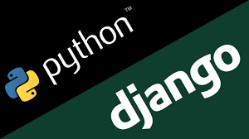
Django is a high-level Python web framework that encourages rapid development and clean, pragmatic design. Django makes it easier to build better web apps quickly and with less code. Django is a web development framework that assists in building and maintaining quality web applications. Django helps eliminate repetitive tasks making the development process an easy and time saving experience.


A Single page application is a web application or website that interacts with the user by dynamically rewriting the current web page with new data from the web server, instead of the ` transitions that make the website feel more like a native app. Single page application (SPA) is a single page (hence the name) where a lot of information stays the same and only a few pieces need to be updated at a time.


Bootstrap is a free and open-source front end development framework for the creation of websites and web apps. The Bootstrap framework is built on HTML, CSS, and JavaScript (JS) to facilitate the development of responsive, mobile-first sites and apps. Bootstrap includes user interface components, layouts, and JS tools along with the framework for implementation.


CSS3 is the latest evolution of the Cascading Style Sheets language and aims at extending CSS2.1. It brings a lot of long-awaited novelties, like rounded corners, shadows, gradients, transitions, or animations, as well as new layouts like multi-columns, flexible box, or grid layouts. Experimental parts are vendor-prefixed, and should either be avoided in production environments, or used with extreme caution as both their syntax and semantics can change in the future.

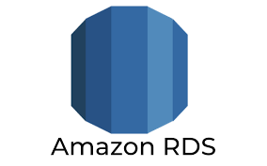
Amazon Relational Database Service (RDS) is a managed SQL database service provided by Amazon Web Services (AWS). Amazon RDS supports an array of database engines to store and organize data. It also helps with relational database management tasks, such as data migration, backup, recovery and patching.

Amazon ElastiCache is a web service that makes it easy to deploy, operate, and scale an in-memory data store and cache in the cloud. The service improves the performance of web applications by allowing you to retrieve information from fast, managed, in-memory data stores, instead of relying entirely on slower disk-based databases.

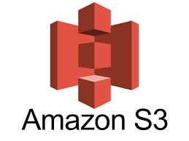
Amazon Simple Storage Service (Amazon S3) is an object storage service that offers industry-leading scalability, data availability, security, and performance. Customers of all sizes and industries can use Amazon S3 to store and protect any amount of data.
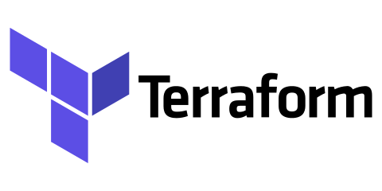
Terraform is an infrastructure as a code (IAAC) tool that allows you to build, change, and version infrastructure safely and efficiently. This includes both low-level components like compute instances, storage, and networking, as well as high-level components like DNS entries and SaaS features.

Amazon DynamoDB is a fully managed proprietary NoSQL database service that supports key–value and document data structures and is offered by Amazon.com part of the Amazon Web Services portfolio. DynamoDB exposes a similar data model to and derives its name from Dynamo, but has a different underlying implementation. Dynamo had a multi-leader design requiring the client to resolve version conflicts and DynamoDB uses synchronous replication across multiple data centers for high durability and availability.

Below is a list of major technologies used in this application:
Area | Technology Used
Backend | Python/Lambda
Presentation Layer | HTML5, CSS, Bootstrap, AJAX, SPA
Database | AWS RDS, AWS Dynamo DB
Caching Layer | AWS Elastic Cache
Document Storage | AWS S3
Traffic Distribution | AWS ELB
Notification Services | AWS SNS, AWS SQS
DNS services | Route 53
Log Monitor & Security | AWS CloudWatch, AWS Cloud Trail, AWS X-Ray, AWS WAF, AWS Firewall Manager, Amazon GuardDuty
Source Code Management | Gitlab/ECR
CI-CD/Deployment Tool | AWS DevOps (Code Pipeline, Code Build, Code Deploy), Docker, Terraform
Container Orchestration | AWS ECS

Figure 1: List of major technologies used

Assumptions

In scope
- The application will support only English language.
- All documentation, exception handling, logging messages etc. will be delivered in English language only.
- Admin users can map roles and permissions through the application.
- Admin users should be able to add/edit/delete the master data.
- Response from the external service will be in JSON format only which includes proper error message as well.
- Third party will be used for Payment gateway, Email and SMS
- The encryption for sensitive data will be used as provided by the Django framework.
- Site speed, page speed and SEO optimization helping you rank high in search

Out of Scope
- No multi-language support will be provided in the system.
- Content creation, adding new pages, copywriting, Logo design and product design will be provided by the Company.
- Insurance policy system already created by YCompany. This Process already electronic and well organized.
- YCompany will handle certification, licensing required for deployment and development of applications.
- The number of agents and internal users are not specified anywhere.
- Test data will be provided by YCompany.
- Existing user’s policy data will be dumped into the new system through a separate process.
- Changes in requirements will be managed through a formal change request process.
- Rental vehicle from the Car Rental partner from customer site itself.
- Any addition/change in the requirements will have a direct impact on estimation.

NFR Considerations

Usability
  - The application should be usable in any devices that support modern day web browsers.
  - Users should have basic knowledge of browsing and surfing internet over web browsers.
  - The system is a simple web application and does not require any special training for end users.
  - The user interface should be consistent throughout the application, and the styling guideline will be provided separately.
  - The system should be end user friendly, easy to use and easy to remember.

How will we achieve Usability?

  - The application will be responsive. We will use some advance framework in frontend technology like as bootstrap, CSS, CSS3.
  - The application navigation layout will be familiar. Familiar layout will make users feel comfortable when browsing your site.
  - The application will use proper heading. Headings (H1) and subheadings (H2) will help break up your content and make the page look better to a user.
  - The application will highlight key features, product, and services.
  - The application will be maintaining a constant theme on every page.

Reliability
  - The system should be robust and highly reliable.
  - The system should be available throughout the day and will be down only during interim releases. The downtime should not exceed the limit states in service contract.
  - In case of errors, user should be presented a user-understandable error message.
- System should have details logs for any activity.
  - System will contain sensitive data for which regular backup has to be taken for the system to be reliable.
  - For any system failure or network failure, transaction will roll back to its previous state.
  - Data tracing in SQL is the part to trace all time logs, activities for the logins and will be used if any manual update of data of track the failure within the system.

How will we achieve Reliability?

  - This system will be use proper application logging. We use cloud watch for logging concept.
  - The system will be used AWS RDS service with MYSQL database. MYSQL Default follow ACID property that is helpful in case of transaction handling.
  - We will use Read and write replica of RDS with async nature and use other sync copy in different AZ as standby mode.
  - In case of API error, we will store into DB and send error Notification to appropriate person.
  - We will Monitor API response time, CPU Utilization, and other stats with Help of Cloud Watch and AWS EC2 monitoring panel.

Performance
  - The offered solution must complete 99% of provided services in less than 5 seconds, over both the peak and non-peak hours.
  - System should have flexible design and it should be able to handle increased load in future.

How will we achieve Performance?

  - The application will be Use of load balancer to improve the performance of application. AWS Load Balancer will be used to manage scalability. Desired number of scalable servers running would be 3. Minimum threshold for CPU utilization on a server is considered as 50%. Minimum threshold for Memory utilization on a server is considered as 50%.
  - The application will be using less HTTP request.
  - The application’s CSS and JS will be Minified. We will use GZIP compression and browser caching.
  - The application will be use CDN for load static content. The application’s images will be optimized like as logo image, and banner image.
  - The application will be use AWS Elastic Cache for Backend caching engine.

Security
    - System must enforce user access controls, stringent security to restrict the unauthorized access via authentication and authorization services.
    - Alert emails will be sent to technical and operation support group if any error or crash occurred in the system. In addition to this proper logging will be also there for any tracing.
    - When deploying on server and communication, HTTP security, cookies encryption, SSL like security mechanism should be well placed to secure the message going to server and back on browser.
    - The system should not provide any authorized access to any data of files stored within the system.

How will we achieve Security?

    - The system will be use SSL certificate for us to create a secure online connection. All URL of website will be accessible via HTTPS.
    - The system will be use strong password policy like as Minimum length policy, Mixture of Letters and numbers, Contain both Uppercase and lowercase.
    - All software’s, those will be use in system will be up to date.
    - The system will be use authentication and authorization with help of DJANGO Framework. All API will use REST Concept with proper header and Proper Message.
    - The system will be backup of DB on schedule Interval and store backup file on proper place like as S3. Backup of all applications shall be taken monthly and shall be part of each minor or major release.
    - The system will be use some open source static analysis tool to detect command injection like as SONARQUBE, PYT or Bandit to regularly perform web security scans to check for website and server vulnerabilities.
    - The system will be deployed on cloud because host that is aware of threats and devoted to keeping your website secure.
    - The system will be use three-layer Architecture and Storage unit will be setup in Private Subnet with limited user access with limited Rights.

Supportability
  - System admin team should be responsible for any installation, release deployment and security updates etc. on the servers.
  - CI must be used to automate the release process in case of full or partial deployment.
  - Server patches or upgrades shall be installed ASAP and must conform the requirement of Eclaim systems. This process shall be happening in off time most likely in mid night so that minimal effect can be visible to users.
  - A monthly planned maintenance activity shall be performed, and every party must be informing about the same.
  - Above activities are for all load balancer servers. And backup of all applications shall be taken monthly and shall be part of each minor or major release.
  - Only system admin shall have edit permissions on the servers.
  - Intended team members shall be able to access and read-write permission on selected release paths only. Read-only access shall be granted for monitoring purpose only.
  - Automated test script shall be prepared and executed before any release.
  - Test cases covering and part of UAT shall be passed before any release.

Auto Scalability
  - Autoscaling is a cloud computing feature that enables organizations to scale cloud services such as server capacities or virtual machines up or down automatically, based on defined situations such as traffic or utilization levels.
  - Auto Scaling feature of AWS shall be used to define the conditions such that when to scale and how much to scale. For Example, if number of concurrent users goes beyond specific limit, then web app shall be added up with one more instance.

Solution Architecture

High Level Solution Diagram

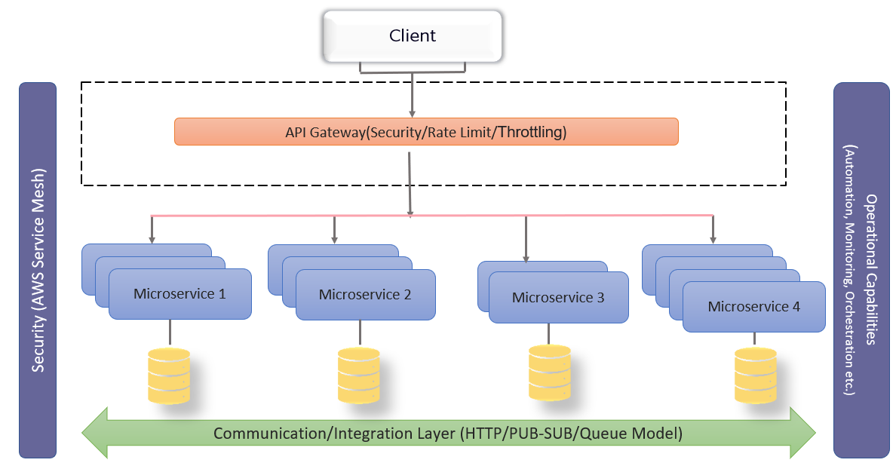

Figure 2: High Level Solution Diagram

Components Description

API Gateway:
An API stands for Application Program Interface, containing the set of tools to build applications. API Gateway is a reverse proxy that accepts all API calls, applies various services to fulfill the calls, and returns the appropriate output. In simple words, an API gateway is a server that summarizes the internal system architecture of the application.

Microservice:
Microservices architecture patterns have their importance for enabling agile development and developing complex applications. Unlike monolithic applications, which have only one set of endpoints, microservices architecture consists of multiple sets of fine-grained endpoints.
Microservices also enable you to interact with a comparatively small and flexible code base, and hence you can decide which bit of code you want to interact with and where it came from.

Cross Cutting Concern
Cross-cutting concerns are part of every project built or being built and so-called Infrastructure. A quick definition of CCC (Cross-cutting concerns), An essential part of software application that cuts across the layers of the application. CCC can include things like Logging, Exception/Error Handling, Caching, Monitoring, Security, Communication, etc. and there’s a list of operations that is an integral part of an application and needs to be performed across the layers. Look at the layered application architecture. It has Data Layer, Business Layer, and UI or Presentation Layer. Those usually managed separately in individual projects but what kept me thinking is the way to manage the cross-cutting. The challenge comes with the fact that CCC is shared across the layer

Application Architecture

Architecture Diagram

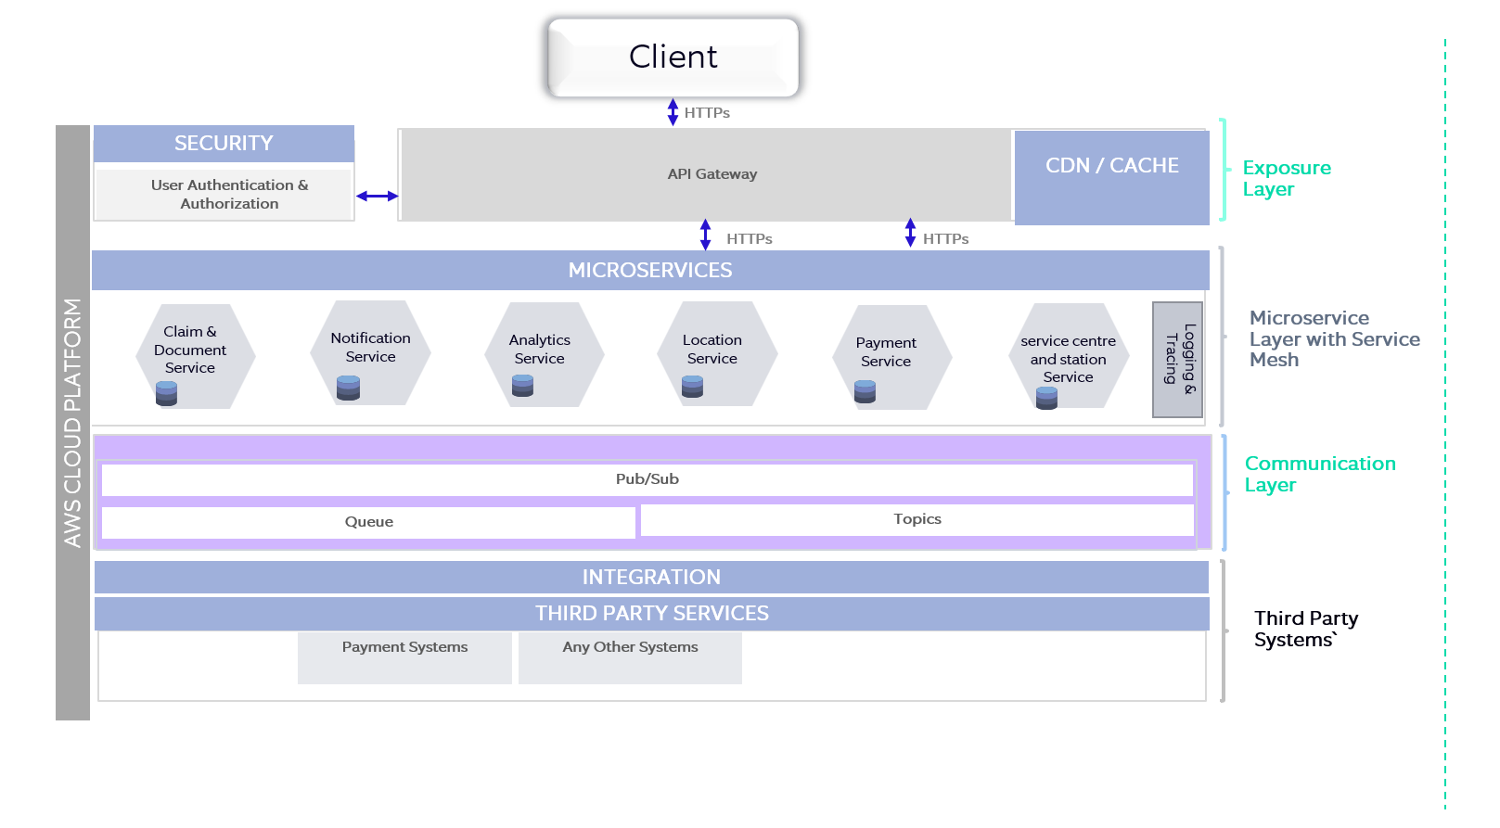
Figure 3: Architecture Diagram

Modules Description

API Gateway:
An API stands for Application Program Interface, containing the set of tools to build applications. API Gateway is a reverse proxy that accepts all API calls, applies various services to fulfil the calls, and returns the appropriate output. In simple words, an API gateway is a server that summarizes the internal system architecture of the application.
The API gateway has responsibilities to provide the application client with API, perform request routing, provide authentication, load balancing, monitoring, composition, and protocol translation. When a client makes a request, the request transmits to the API gateway, and further, it routes to appropriate microservices.
It also has other responsibilities such as authentication, monitoring, load balancing, caching, request shaping and management, and static response handling. API Gateway is also responsible for request routing, composition, and protocol translation.

Microservices Decomposition Pattern
Think about that our monolithic application is large and complex application and want to use the microservice architecture. With the microservice architecture, we are going to split the application as a set of loosely coupled services to accelerate software development processes.
How to decompose an application into services?
There are some Prerequisite of decomposition of microservices.
- Services must be cohesive. A service should implement a small set of strongly related functions.
- Services must be loosely coupled — each service as an API that encapsulates its implementation.

Sidecar Design Pattern:
Segregating the functionalities of an application into a separate process can be viewed as a Sidecar pattern. The sidecar design pattern allows you to add a number of capabilities to your application without additional configuration code for third-party components.
As a sidecar is attached to a motorcycle, similarly in software architecture a sidecar is attached to a parent application and extends/enhances its functionalities. A sidecar is loosely coupled with the main application.
Each microservice needs to have functionalities like observability, monitoring, logging, configuration, circuit breakers, and more. All these functionalities are implemented inside each of these microservices using some industry standard third-party libraries.

Benefits of Using a Sidecar Pattern:
- Reduces the complexity in the microservice code by abstracting the common infrastructure-related functionalities to a different layer.
- Reduces code duplication in a microservice architecture since you do not need to write configuration code inside each microservice.
- Provide loose coupling between application code and the underlying platform.

How Does the Sidecar Pattern Work?
The service mesh layer can live in a sidecar container that runs alongside your application. Multiple copies of the same sidecar are attached alongside each of your applications.
All the incoming and outgoing network traffic from an individual service flows through the sidecar proxy. As a result, the sidecar manages the traffic flow between microservices, gathers telemetry data, and enforces policies. In a sense, the service is not aware of the network and knows only about the attached sidecar proxy. This is really the essence of how the sidecar pattern works — it abstracts away the network dependency to the sidecar.

Service Mesh:
A service mesh is a platform layer on top of the infrastructure layer that enables managed, observable, and secure communication between individual services. This platform layer enables companies or individuals to create robust enterprise applications, made up of many microservices on a chosen infrastructure. Service meshes are transparent to the application. The service mesh monitors all traffic through a proxy.

Features of Service Mesh
- Encryption: - The service mesh can encrypt and decrypt requests and responses, removing that burden from each of the services. The service mesh can also improve performance by prioritizing the reuse of existing, persistent connections, which reduces the need for the computationally expensive creation of new ones. The most common implementation for encrypting traffic is mutual TLS (mTLS), where a public key infrastructure (PKI) generates and distributes certificates and keys for use by the sidecar proxies.
- Authentication and authorization: -The service mesh can authorize and authenticate requests made from both outside and within the app, sending only validated requests to instances.
- Support for the circuit breaker pattern:- The service mesh can support the circuit breaker pattern, which isolates unhealthy instances, then gradually brings them back into the healthy instance pool if warranted.
- Distributed traces: - A service mesh can generate distributed trace spans for each service within it. Use these traces to follow a single request through the mesh across multiple services and proxies.
- Access logs: - A service mesh can generate a full access log that includes all the service calls, including the source of the call and its destination which allows for auditability at the service level.

Database Design pattern:
Microservices architecture is constantly growing. It brings a lot of benefits, especially over obsolete monolith architecture. On the other hand, there are multiple challenges while developing a project using microservices. One of the most important concerns is database design.
There are below main options for organizing the databases when using microservices architecture:
- Database per service
- Shared database
- SAGA design Pattern
- CQRS
- Event Sourcing

Database per service: -
By definition, microservices should be loosely coupled, scalable, and independent in terms of development and deployment. Therefore, the database per service is a preferred approach as it perfectly meets those requirements.
The idea is simple. Each microservice has its own data store (whole schema or a table). Other services can’t access the data stores that they don’t own. Such a solution brings a lot of benefits.
First of all, changes to an individual database don’t impact other services. Thus, there isn’t a single point of failure in the application. So, to speak, the application is more resilient.
Secondly, individual data stores are easier to scale. Moreover, the domain’s data is encapsulated within the microservice. Therefore, it’s easier to understand the service with its data as a whole. It’s especially important for new members of a development team. It will take less time and effort for them to fully understand the area they’re responsible for.
Finally, with the database per service, we’re able to use polyglot persistence. It means that we can use different database technologies for different microservices. So, one service may use an SQL database and another one a NoSQL database. That’s feature allows using the most efficient database depending on the service requirements and functionality.

Shared Database: -
A shared database is considered an anti-pattern. Although, it’s debatable. The point is that when using a shared database, the microservices lose their core properties: scalability, resilience, and independence. Therefore, a shared database is rarely used with microservices.
When a shared database seems to be the best option for the microservices project, we should rethink if we really need the microservices
Microservices with shared databases can’t easily scale. What is more, the database will be a single point of failure. Changes related to the database could impact multiple services. Besides, microservices won’t be independent in terms of development and deployment as they connect to and operate on the same database.

Saga Pattern
We mentioned earlier those spanning transactions across microservices can be problematic. In simple words, the transaction will be successful only if all related services successfully execute their own part. In case of a failure in one service, the whole transaction should fail. Moreover, in that case, services that already did their part should roll back the changes.
In general, that’s what the saga pattern is responsible for. The Saga pattern is a sequence of local transactions that represent a single distributed transaction. Each service executes a local transaction. If the local transaction ends successfully, an event or message is published that triggers the next local transaction in the sequence. In case of failure, saga provides compensating transactions that roll back the changes.
There are two types of implementing the saga pattern:
- Orchestration – central controller (orchestrator) manages all interactions between microservices
- Choreography – decentralized technique of broadcasting events

CQRS
CQRS (Command Query Responsibility Segregation) helps with another important feature: querying related data from multiple data stores. Moreover, it simplifies the complexity of business logic by separating concerns. Additionally, it helps with the scalability of microservices.
The idea is simple. We’re separating the data layer from the business logic layer. Further, classes can only write to the database (Command) or read from it (Query). So, a single class can’t do both. That approach results in many benefits. The code is clearer and easier to maintain or extend. Different components can be separately optimized, developed, and what’s especially important, scaled.
Subsequently, the components are loosely coupled, and work can be effectively split between developers or teams. Finally, the application divided into components is easier to test. There isn’t one correct way to implement the CQRS pattern. The implementation can base on the domain, requirements, framework, actual state of the project, etc. CQRS is often used alongside the Event Sourcing pattern. Let’s describe that one.

Event Sourcing
A lot of modern applications rely on events for various purposes. For example, as we mentioned earlier, a service in a saga sequence atomically updates the database and publishes an event or message. Event Sourcing makes use of applications events.
Event Sourcing is a technique of representing the state by persisting state-changing events. Every time the business entity changes, the event is persisted in the event store.
As the name suggests, the event site is a database for events. It can be SQL, NoSQL, or any other way that is suitable for the project. Moreover, the event store can act as a message broker. All interested components subscribe to it. When an event is persisted, the event store delivers information to all subscribers. Publishing an event is a single atomic operation. Therefore, it provides reliability and atomicity of database operation across microservices.
Furthermore, it creates a complete audit log. In case of any problem or bug, it’s easy to research the state changes and eventually restore the valid state. Thus, debugging is less complex. Additionally, event sourcing can avoid impedance mismatch between object-oriented and relational data. To sum up, event sourcing can be a great help in microservices architecture or any event-driven application.

Network Architecture

Network Diagram

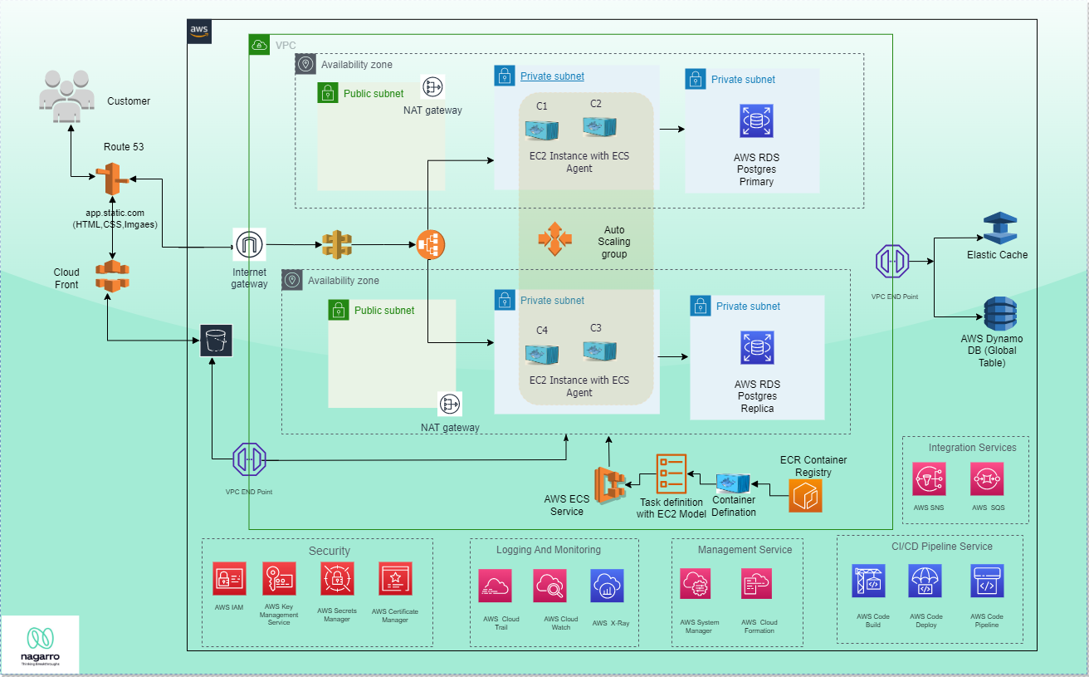

Figure 4: Network Diagram

Network Component Description

Route 53
Amazon Route 53 is a highly available and scalable Domain Name System (DNS) web service. You can use Route 53 to perform three main functions in any combination: domain registration, DNS routing, and health checking.

ELB
Elastic Load Balancing automatically distributes your incoming traffic across multiple targets, such as EC2 instances, containers, and IP addresses, in one or more Availability Zones. It monitors the health of its registered targets, and routes traffic only to the healthy targets. Elastic Load Balancing scales your load balancer as your incoming traffic changes over time. It can automatically scale to the vast majority of workloads.

EC2 Instance Auto scaling group
Amazon EC2 Auto Scaling helps you ensure that you have the correct number of Amazon EC2 instances available to handle the load for your application. You create collections of EC2 instances, called Auto Scaling groups. You can specify the minimum number of instances in each Auto Scaling group, and Amazon EC2 Auto Scaling ensures that your group never goes below this size. You can specify the maximum number of instances in each Auto Scaling group, and Amazon EC2 Auto Scaling ensures that your group never goes above this size

Cloud Watch
Amazon CloudWatch monitors your Amazon Web Services (AWS) resources and the applications you run on AWS in real time. You can use CloudWatch to collect and track metrics, which are variables you can measure for your resources and applications.
The CloudWatch home page automatically displays metrics about every AWS service you use. You can additionally create custom dashboards to display metrics about your custom applications and display custom collections of metrics that you choose.

RDS
Amazon Relational Database Service (Amazon RDS) is a web service that makes it easier to set up, operate, and scale a relational database in the AWS Cloud. It provides cost-efficient, resizable capacity for an industry-standard relational database and manages common database administration tasks.
Amazon RDS uses the MariaDB, Microsoft SQL Server, MySQL, Oracle, and PostgreSQL DB engines' built-in replication functionality to create a special type of DB instance called a read replica from a source DB instance. The source DB instance becomes the primary DB instance. Updates made to the primary DB instance are asynchronously copied to the read replica. You can reduce the load on your primary DB instance by routing read queries from your applications to the read replica.

ECS
Amazon Elastic Container Service (Amazon ECS) is a highly scalable and fast container management service. You can use it to run, stop, and manage containers on a cluster. With Amazon ECS, your containers are defined in a task definition that you use to run an individual tasks or task within a service. In this context, a service is a configuration that you can use to run and maintain a specified number of tasks simultaneously in a cluster. You can run your tasks and services on a serverless infrastructure that's managed by AWS Fargate. Alternatively, for more control over your infrastructure, you can run your tasks and services on a cluster of Amazon EC2 instances that you manage.

Elastic cache
Amazon ElastiCache is a web service that makes it easier to set up, operate, and scale a distributed cache in the cloud.
With ElastiCache, customers get all of the benefits of a high-performance, in-memory cache with less of the administrative burden involved in launching and managing a distributed cache. The service makes setup, scaling, and cluster failure handling much simpler than in a self-managed cache deployment.

S3 Bucket
Amazon Simple Storage Service (Amazon S3) is an object storage service that offers industry-leading scalability, data availability, security, and performance. Customers of all sizes and industries can use Amazon S3 to store and protect any amount of data for a range of use cases, such as data lakes, websites, mobile applications, backup and restore, archive, enterprise applications, IoT devices, and big data analytics. Amazon S3 provides management features so that you can optimize, organize, and configure access to your data to meet your specific business, organizational, and compliance requirements.

SNS
Amazon Simple Notification Service (Amazon SNS) is a managed service that provides message delivery from publishers to subscribers (also known as producers and consumers). Publishers communicate asynchronously with subscribers by sending messages to a topic, which is a logical access point and communication channel. Clients can subscribe to the SNS topic and receive published messages using a supported endpoint type, such as Amazon Kinesis Data Firehose, Amazon SQS, AWS Lambda, HTTP, email, mobile push notifications, and mobile text messages (SMS).

Docker
Docker is an open platform for developing, shipping, and running applications. Docker enables you to separate your applications from your infrastructure so you can deliver software quickly. With Docker, you can manage your infrastructure in the same ways you manage your applications. By taking advantage of Docker’s methodologies for shipping, testing, and deploying code quickly, you can significantly reduce the delay between writing code and running it in production.

Deployment Architecture

We use Continuous Integration (CI) so that the isolated changes are immediately tested and reported on when they are added to a larger code base. This will also help in automating the testing and build a document trail. This will make sure that the code individual developers work on doesn’t divert too much. The key goals are to find and address bugs quicker, improve software quality, and reduce the time it takes to validate and release new updates.

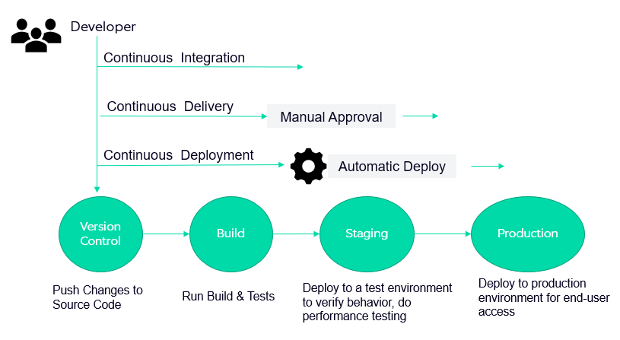

Figure 5: CI CD Process

Continuous Integration
With CI, developers will frequently commit to the shared repository using the version control system (We would be using GitLab). The continuous integration service running on the integration server detects commits to the shared repository, and automatically builds and runs unit tests on the new code changes to immediately surface any functional or integration errors.

Continuous Delivery
We will implement continuous delivery so that all the changes including new features, configuration changes, bug fixes and experiments can be deployed to production safely and quickly in a sustainable way. For this we need to ensure that our code is always in a deployable state. This will help us achieve low risk releases, faster time to market, higher quality, lower costs, and better product.

AWS CI-CD Pipeline
The whole development cycle will be based on the dev-ops model with the help of dev-ops tools as well

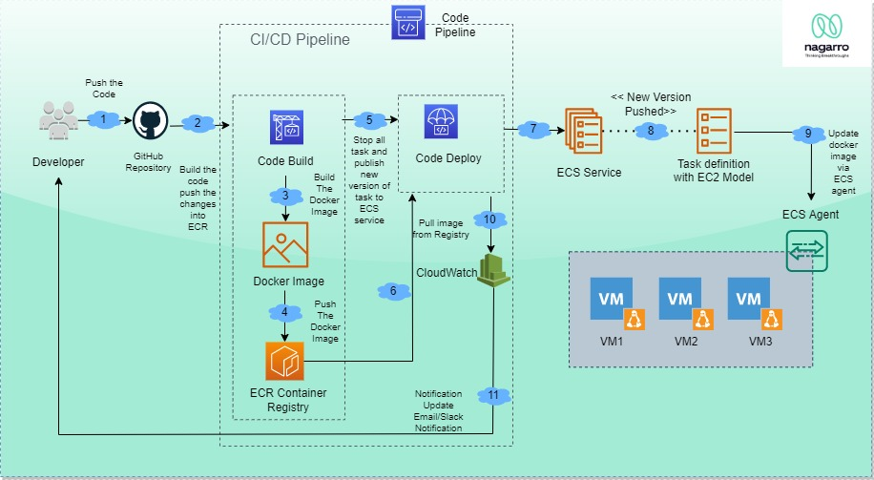

Figure 6 CI/CD Diagram

AWS CI/CD provides us with various interfaces and tools in order to automate the entire process.
- We will create a gitlab repository or use an existing one
- Dev team have the responsibility to commit the code to Dev-Branch
- Gitlab pipelines will trigger automatically and will map with the job enabled for a specific task
- Gitlab Pipeline will compile code and it’s called build phase of the task.
- In build phase, we will create docker image, tag that image and push into docker repository.
- Latest docker image will be deployed on staging environment and test some test cases like as integration testing and load testing.
- After this process, a notification will be suited to a specific channel like as slack and email format.
- After the staging phase, if code is working fine in staging server with unit testing, Same docker image will be deployed on the production server
- The code is ready to be deployed to any other environment.
- DevOps team will be trigger production pipeline to trigger latest code on production server. After this, message notification will be triggered.

Glossary

Terms

ADJUSTER: Carries out the process of investigation and settlement of damages for the Insured.
BACK OFFICE: It is the controlling office that has no direct business but controls and monitors the different sales offices. Primary functions include checking accounting records, ensuring compliance by the marketing offices to all the regulatory guidelines, and company guidelines and directives. It is also responsible for communicating with the sales offices about matters related to the needs of either side.
BAR CHART: This is a graphical representation of information and highlights the important features of frequency distributions covering different risks and possible consequences.
DISCLOSURE: Duty of the insured individual and his/her broker to provide the underwriter details on all material events prior to acceptance of the risks
ACCEPTANCE: An event where an insurer accepts an application and issues a policy that will safeguard the applicant from risks stated in the policy.
ACCIDENTAL MEANS: A clause in the policy which requires the cause of injury / death of the Insured to be accidental and not premeditated. This clause helps reduce fraudulent incidents.
BENEFICIARY: Person/s or entity named in the insurance policy as the recipient of the proceeds in the event of the demise of the insured

REFERENCES
- https://developer.mozilla.org/en-US/docs/Learn/Server-side/Django/Authentication
- https://medium.com/must-know-computer-science/basic-concepts-you-need-to-know-about-building-large-scale-distributed-system-5956a90c7ad2
- https://www.digitalocean.com/community/tutorials/how-to-set-up-replication-in-mysql
- https://serverguy.com/comparison/pros-cons-rds-vs-ec2-mysql-aws/



Manish Kumar
Staff Engineer
manish.kumar19@nagarro.com

